Brute-Force String Matching

Searching for a given word in a text is called string matching. Given a string of n characters called the text and a string of m characters (m ≤ n) called the pattern, find a substring of the text that matches the pattern. Find i - the index of the leftmost character of the first matching substring in the text - such that t_{i} = p0,...,t_{i+j} = p_{j} ,...,t_{i+m−1} = p_{m−1}:
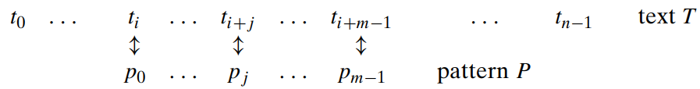

Align the pattern against the first m characters of the text and start matching the corresponding pairs of characters from left to right until either all the m pairs of the characters match. In the next iteration, shift the pattern one position to the right and resume the character comparisons, starting again with the first character of the pattern and its counterpart in the text.

ALGORITHM BruteForceStringMatch(T [0..n − 1], P[0..m − 1])
//Implements brute-force string matching
//Input: An array T [0..n − 1] of n characters representing a text and
// an array P[0..m − 1] of m characters representing a pattern
//Output: The index of the first character in the text that starts a
// matching substring or −1 if the search is unsuccessful
for i ← 0 to n − m do
j ← 0
while j<m and P[j ] = T [i + j ] do
j ← j + 1
if j = m return i
return −1

Example of brute-force string matching. The pattern’s characters that are compared with their text counterparts are in bold type:
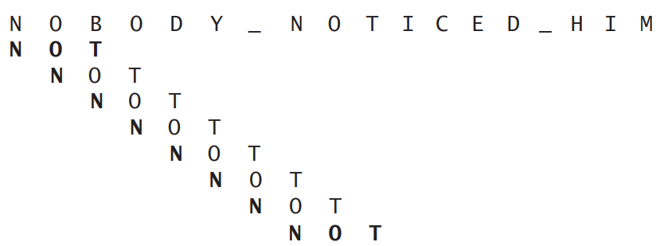

Basic Operation: Comparison
Best Case Time Complexity:
If the pattern is present in the 1st position of the text, then the number of comparisons made is equal to number of characters in the pattern.
.:Time complexity is given by,

Worst Case Time Complexity:
If all the characters of the pattern matches with the text expect the last character, the algorithm may have to make all m comparisons before shifting the pattern and this repeats for each of the n-m+1 tries.
ie. (P is not found or is found in the last m characters of T, so the outer for loop is executed n-m+1 times, and the inner loop is executed m times. 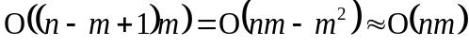)
The time complexity is given,

Average Case Time Complexity:
The average case efficiency should be considerably better then the worst-case efficiency. For searching in random texts, it has been shown to be linear.

